Advertisement Goals:
The goal is to build awareness and attract businesses and concerned citizens. Build credibility, emphasize your project’s transparency, accountability, and legitimacy. Share detailed information about how the funds will be used and the outcomes they will achieve. Provide clear, accessible information about how drones make a difference in modern military operations. The last but not the least is to encourage action.
Headline:
Empower the Frontline: Precision and Safety with Our Drone Solutions
Tagline:
Smart sky, Safer future - Your Contribution Makes It Possible
Unique Selling Proposition (USP):
- Security and Reliability - built with robust encryption and anti-hacking measures to ensure mission integrity also optimized for harsh environments and long-term deployments.
- Cost-Effectiveness - A high-performance solution that maximizes operational outcomes at a competitive cost
Call-to-Action (CTA):
Act before it’s too late. Your donation matters.
Advertisement Copy:
Join us in shaping the future advanced military drone technology. Our advanced software empowers drones with unmatched precision and reliability, ensuring safer missions and stronger defence.
Your support can make a difference. Every contribution helps us enhance mission success while keeping our heroes out of harm's way. Together, we can deliver smarter solutions and stronger protection for those on the frontline.
Act before it’s too late. Your donation matters.
Social Media Platforms:
Instagram is a visual platform, so it’s perfect place for posts and flyers. There you can put it in target advertisement system, create post or reel. This social media is perfect place for collecting engagement, for examples likes, comments and sharing.
Also, I would like to use Telegram for the same high rates of engagement. Telegram provides direct line of communication with supporters through channels and groups that’s why they can easily receive notification. Also this is perfect place to create space for supporters to connect, share ideas, and stay motivated.
Success Metrics:
I would measure the success of advertisement through number of donations, number of people who saw advertisement, and social media engagement in general, as likes, comments and sharings. Measure the percentage of people who clicked on your links from ads, posts, or Telegram messages.
Also, calculate the cost of acquiring each new donor or supporter through advertising and comparing the amount raised to the cost of running your campaign (Instagram ads).
Script for reels:
A shot from the beginning of the runway, directed towards the sky. Different models of drones start flying out one after another (for example, 10 Mavik flew out, and then other models in such packs). Their names are displayed in the middle and then how many drones have already been made. When they have all flown out, a bold text appears on the screen with Tagline and CTA (Act before it’s too late. Your donation matters.)
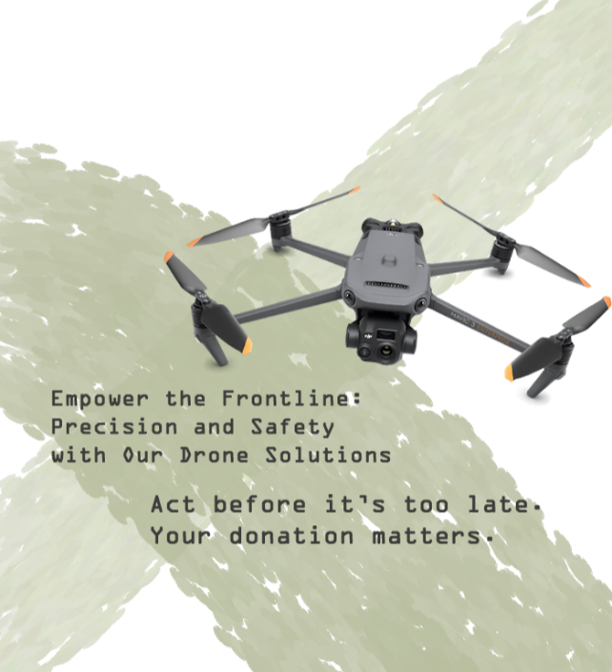
Instagram Post:

